**EPA’s Navigable Waters Protection Rule Defines Waters of the U.S.**

EPA and the U.S. Army have finalized their definition of the Waters of the United States (WOTUS) through a new final rule called the Navigable Waters Protection Rule.

The definition of WOTUS has been at the point of contention between regulators, industry and environmental groups since the Clean Water Act amendment in 2015.   The definition has been at the heart of a number of legal battles, and an item of regulatory enforcement uncertainty.

“[The Navigable Waters Protection Rule] clearly delineates where federal regulations apply and gives states and local authorities more flexibility to determine how best to manage waters within their borders,” said EPA in a published fact sheet about the new rule.

What Is Included?

Once proposed as six categories, the final rule was narrowed to four major categories of waters to be included:

**Territorial Seas and Traditional Navigable Waters**

Included are bodies of water such as the Atlantic Ocean, Mississippi River, Great Lakes, large rivers and lakes, tidal waters, tidally influenced waterbodies including wetlands, along coastlines — used in interstate or foreign commerce.

**Tributaries**

These are rivers and streams that flow to traditional navigable waters either directly or through other non-jurisdictional surface waters. The flow must be perennial (flowing continuously) or intermittent (flowing continuously during certain times of the year), not just when it rains.

These tributaries can connect through structures such as culverts, spillways, and debris piles. Ditches can be tributaries if they satisfy the perennial or intermittent flow requirements and could be considered an artificial channel used to convey water when they are tributaries or built in adjacent wetlands.

**Lakes, Ponds and Impoundments of Jurisdictional Waters**

These are included when they are traditional navigable waters like the Great Salt Lake in Utah or where they contribute a perennial or intermittent flow of water. Lakes and ponds flooded by an included WOTUS in a typical year would be included.

However, lakes, ponds and impoundments must have a surface water connection to a jurisdictional water body. If they are only flooded by stormwater runoff from fields, or if they lose their water only through evaporation, underground seepage or use, they wouldn’t be included.

**Adjacent Wetlands**

Wetlands are adjacent and included if they:

* Physically touch other included WOTUS;
* Are separated from an included WOTUS by a natural berm, bank or dune;
* Are flooded by an included WOTUS in a typical year;
* Are separated from an included WOTUS by an artificial dike, barrier or similar structure that allows direct connection between the wetland and the WOTUS through a culvert, flood gate, pump, or similar; or,
* Are separated by a road or similar structure where there is an allowance for direct surface connection during a typical year.

What is NOT Included?

The below are not included as long as they do not meet the above definitions, and are upland and in non-jurisdictional areas.

* **Groundwater**, including drains in agricultural lands;
* **Ephemeral features**: springs, streams, swales, gullies, rills and pools;
* **Stormwater**: diffuse stormwater runoff and directional sheet flow over upland as well as stormwater control features excavated or constructed in upland to convey, treat, infiltrate, or store stormwater runoff;
* **Farm and roadside ditches**;
* **Prior converted cropland** (except in the case where the cropland has been abandoned/not used for agricultural purposes in the previous five years and has reverted to wetlands);
* **Artificially irrigated areas** including flooded fields for agricultural purposes;
* **Artificial lakes and ponds** including water storage reservoirs and farm irrigation, stock watering and log cleaning ponds;
* **Water-filled depressions** incidental to construction or mining and pits for fill, sand, and gravel;
* **Groundwater recharge, water reuse, and wastewater recycling structures** (detention, retention and infiltration basins and ponds); and,
* **Waste treatment systems**, that is, lagoons, treatment ponds, settling and cooling ponds, and all components designed to convey or retain, concentrate, settle, reduce or remove pollutants either actively or passively from wastewater or stormwater prior to discharge.

Representatives of the agricultural community see this new rule as a win for them as it provides some clarity for their industry and relieves some of the potential impacts the 2015 version would have put on them. Many of the non-included features are agricultural-based.

What’s a Typical Year?

The phrase “typical year” is used widely throughout the definitions. In this rule, typical year means the normal periodic range of precipitation and other climactic variables based on data for the past 30 years. So, some areas which have non-typical flooding or non-typical drought during some calendar years may or may not be included depending on what is “typical.”

What Really Matters: What Are Your Local Laws?

The Navigable Waters Protection Rule defines the requirements of federal law. However, some states like California have developed their own regulations and definitions that are stricter and the federal law allows for that. Be aware of what’s required locally, and that’s the rule you’ll need to follow. However, having this clearer definition of the federal law may be a help in determining what the differences are locally.

**EPA and Army Define Waters of the U.S.**

EPA and the U.S. Army have published their revised definition of the Waters of the United States (WOTUS). The definition of WOTUS has been at the point of contention between regulators, industry and environmental groups since the Clean Water Act amendment in 2015.   The definition has been at the heart of a number of legal battles, and an item of regulatory enforcement uncertainty. The rules containing it were in a state of stay by the Supreme Court.

“This proposed rule would provide clarity, predictability and consistency so that regulators and the public can understand where the Clean Water Act applies — and where it does not,” EPA says in a published fact sheet about the new rule, “…there is a clear distinction between federal waters and waters subject to the sole control of the states and tribes.”

What Is Included in WOTUS?

The proposed rule lists six categories of waters to be included:

**Traditional Navigable Waters**

This includes territorial seas such as the Atlantic Ocean, Mississippi River, Great Lakes, large rivers and lakes, tidal waters, tidally influenced waterbodies including wetlands, along coastlines — used in interstate or foreign commerce.

**Tributaries**

These are rivers and streams that flow to traditional navigable waters either directly or through other non-jurisdictional surface waters. The flow must be perennial or intermittent, not just when it rains.

**Certain Ditches**

A ditch in this rule would be an artificial channel used to convey water when they are tributaries or built in adjacent wetlands. They would also be included if they are traditional navigable waters like the Erie Canal.

**Certain Lakes and Ponds**

These are included when they are traditional navigable waters like the Great Salt Lake in Utah or where they contribute intermittent flow to a traditional navigable water so water is conveyed in a perennial or intermittent flow. Lakes and ponds flooded by an included WOTUS are also included.

**Impoundments**

Impoundments, or dammed water/reservoirs made from WOTUS are included.

**Adjacent Wetlands**

Wetlands that physically touch other included WOTUS are included if they result from inundation from a WOTUS or if there is perennial or intermittent flow between the wetland and a WOTUS.

What is NOT Included

Anything that doesn’t meet the above definitions, and:

* Groundwater;
* Wetlands which are not adjacent to WOTS or are separated by a berm, levee or upland and do not have a surface water connection;
* Farm and roadside ditches;
* Prior converted cropland (except in the case where the cropland has been abandoned/not used for previous five years and has reverted to wetlands);
* Ephemeral features (wetlands, springs, streams, ponds, lakes, etc.) that only have water in them during or in response to rainfall;
* Stormwater control features excavated or constructed in upland to convey, treat, infiltrate, or store stormwater runoff;
* Wastewater recycling structures such as detention, retention, and infiltration basis and ponds, and groundwater recharge basins when they’re constructed in upland; and,
* Waste treatment systems, that is, lagoons, treatment ponds, settling and cooling ponds, and all components designed to convey or retain, concentrate, settle, reduce or remove pollutants either actively or passively from wastewater or stormwater prior to discharge.

*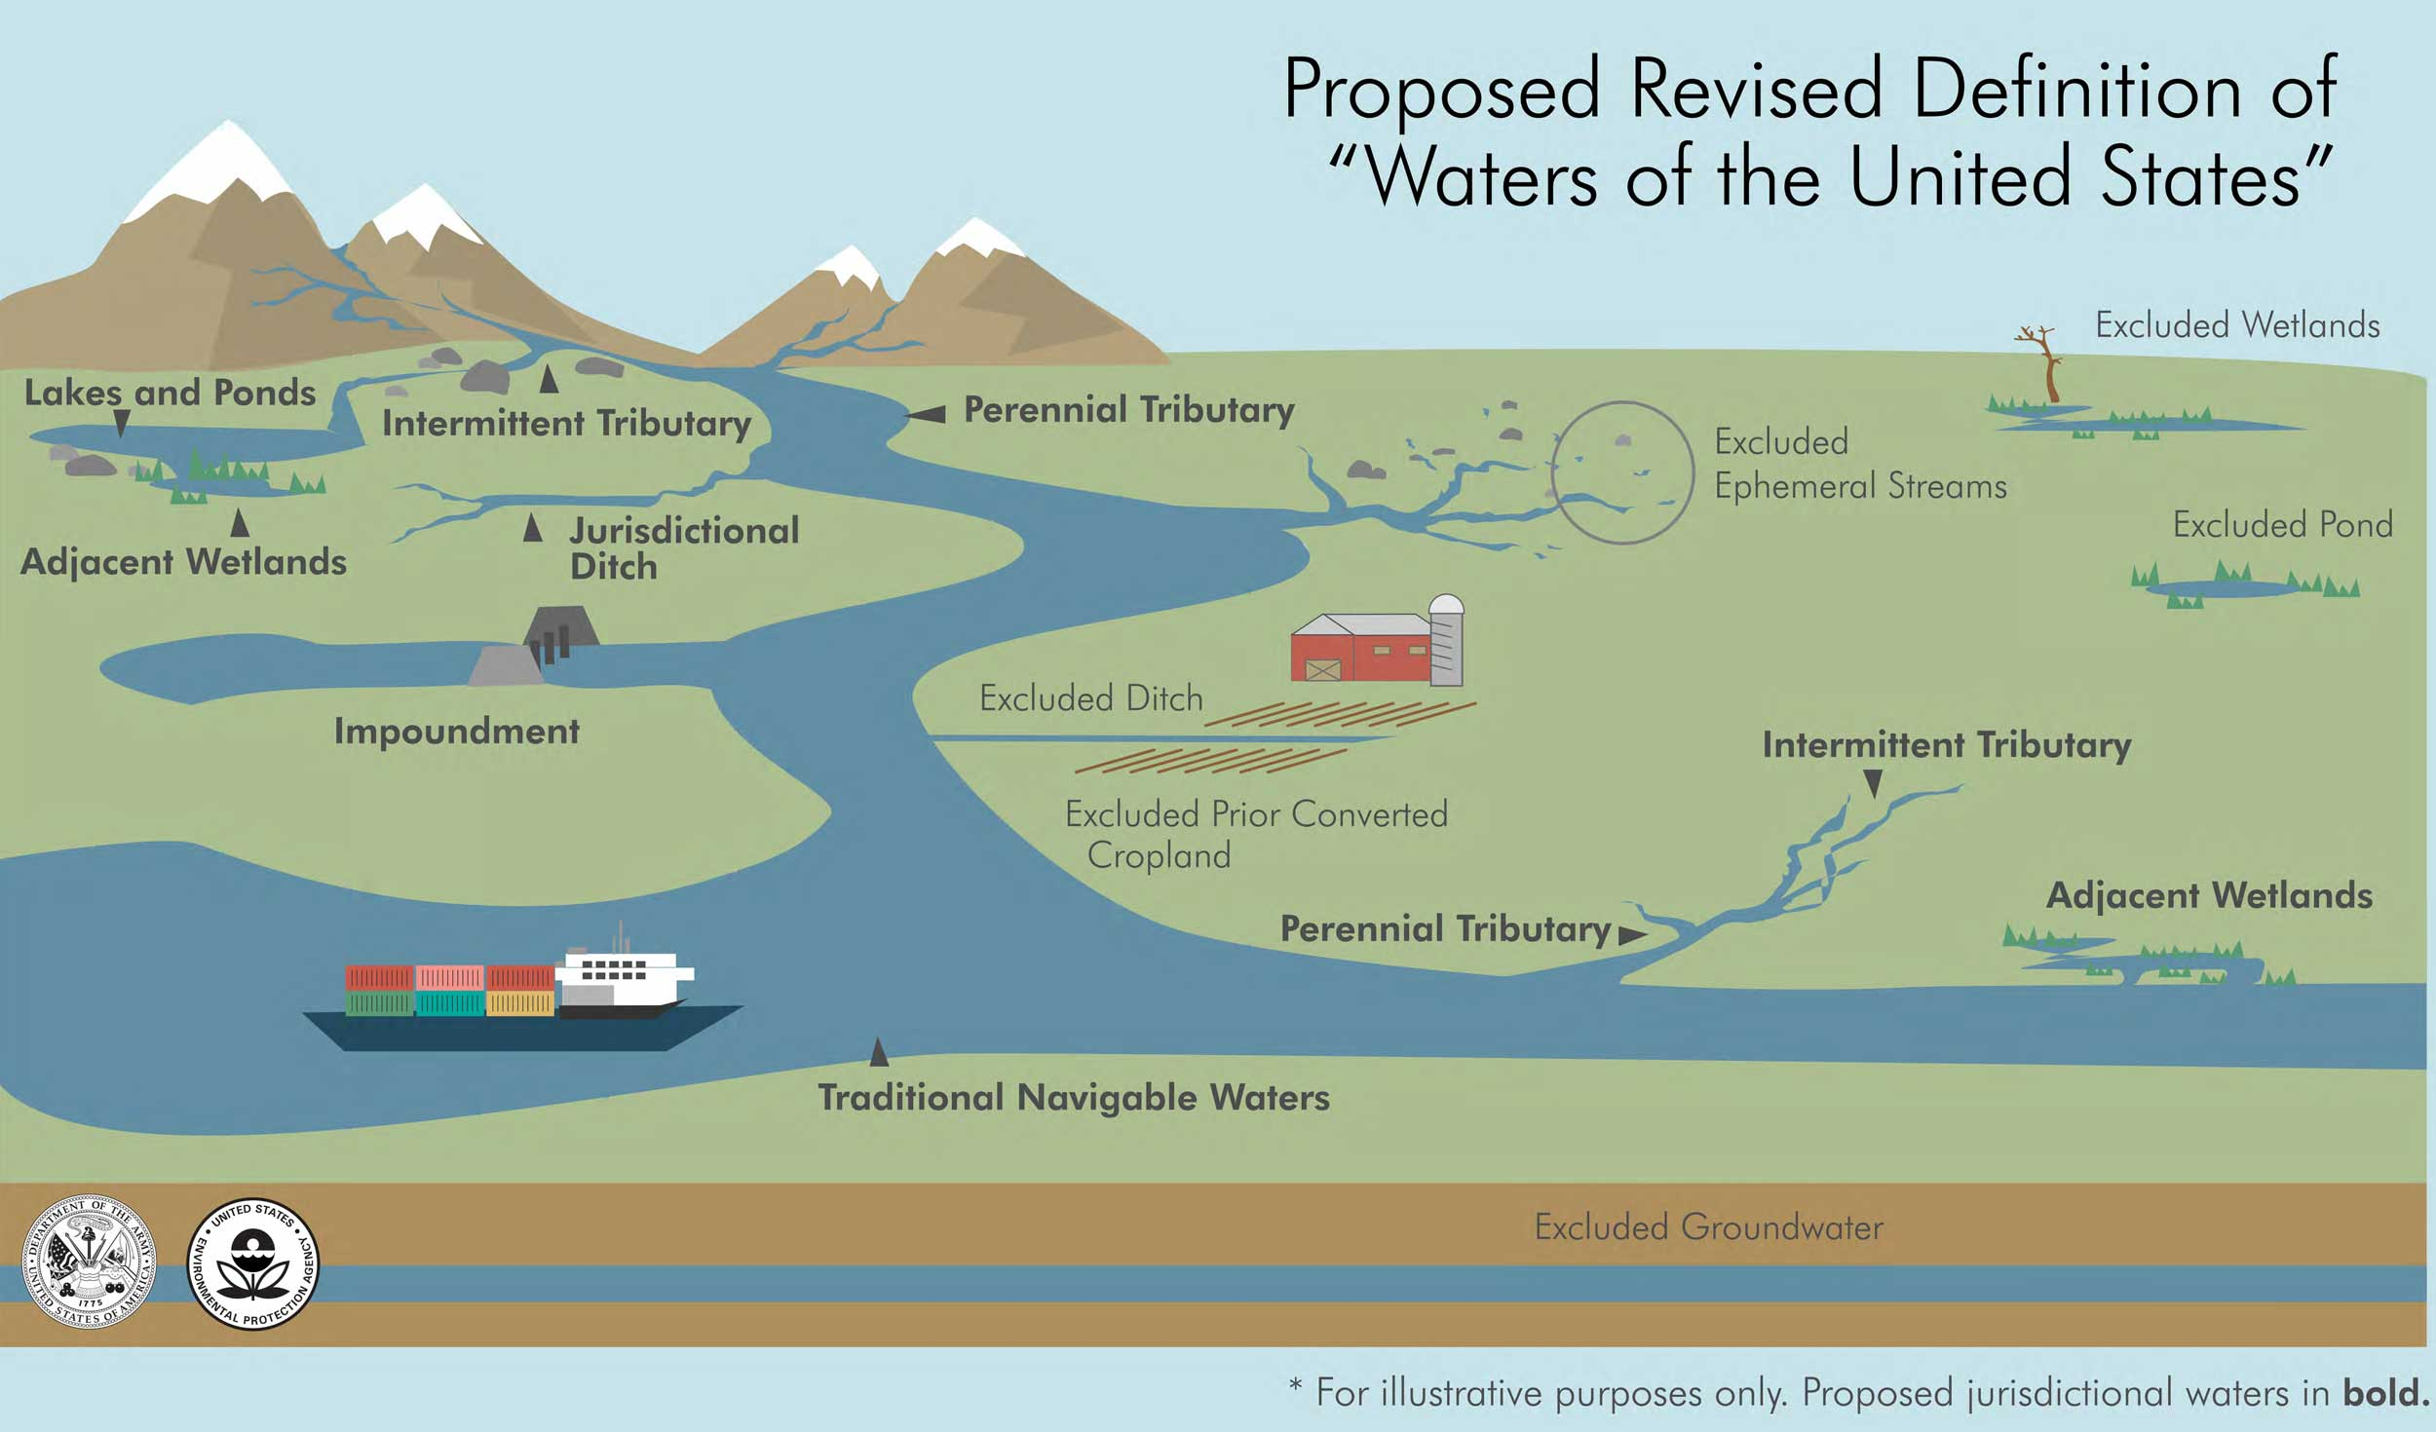Source: EPA.gov*